# **Audio Deep Learning : Sound Classification**

For the project I have used the “UrbanSound8K” dataset for the Audio Deep learning using classification dataset .

The UrbanSound8K dataset that consists of a corpus of ordinary sounds recorded from day-to-day city life. The sounds are taken from 10 classes such as drilling, dogs barking, and sirens. Each sound sample is labeled with the class to which it belongs.

After downloading the dataset, we see that it consists of two parts:

* **Audio files** in the ‘*audio*’ folder: It has 10 sub-folders named ‘*fold1*’ through ‘*fold10*’. Each sub-folder contains a number of ‘*.wav*’ audio samples eg. ‘*fold1/103074–7–1–0.wav*’
* **Metadata** in the ‘metadata’ folder: It has a file ‘*UrbanSound8K.csv*’ that contains information about each audio sample in the dataset such as its filename, its class label, the ‘fold’ sub-folder location, and so on. The class label is a numeric Class ID from 0–9 for each of the 10 classes. eg. the number 0 means air conditioner, 1 is a car horn, and so on.

The samples are around 4 seconds in length. Here’s what one sample looks like:

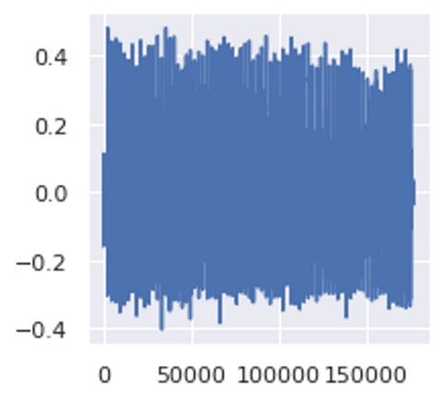

The recommendation of the dataset creators is to use the folds for doing 10-fold cross-validation to report metrics and evaluate the performance of your model. However, since our goal in this article is primarily as a demo of an audio deep learning example rather than to obtain the best metrics, we will ignore the folds and treat all the samples simply as one large dataset.

# **Prepare training data**

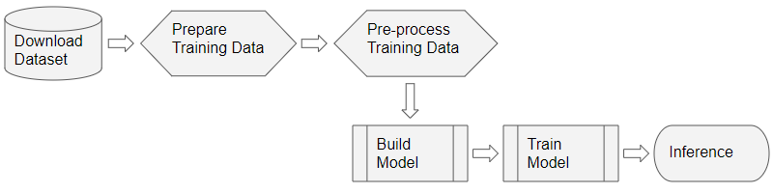

The training data for this problem will be fairly simple:

* The features (X) are the audio file paths
* The target labels (y) are the class names

Since the dataset has a metadata file that contains this information already, we can use that directly. The metadata contains information about each audio file.

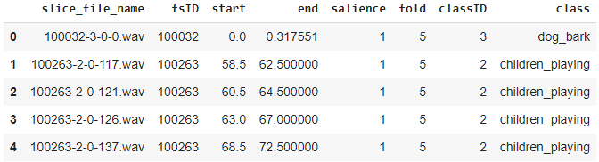

This gives us the information we need for our training data.

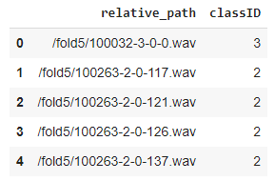

## **Scan the audio file directory when metadata isn’t available**

Many datasets consist of only audio files arranged in a folder structure from which class labels can be derived. To prepare our training data in this format, we would do the following:

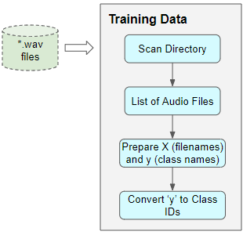

* Scan the directory and prepare a list of all the audio file paths.
* Extract the class label from each file name, or from the name of the parent sub-folder
* Map each class name from text to a numeric class ID

With or without metadata, the result would be the same — features consisting of a list of audio file names and target labels consisting of class IDs.

**Audio Pre-processing: Define Transforms**

This training data with audio file paths cannot be input directly into the model. We have to load the audio data from the file and process it so that it is in a format that the model expects.

This audio pre-processing will all be done dynamically at runtime when we will read and load the audio files. This approach is similar to what we would do with image files as well. Since audio data, like image data, can be fairly large and memory-intensive, we don’t want to read the entire dataset into memory all at once, ahead of time. So we keep only the audio file names (or image file names) in our training data.

Then, at runtime, as we train the model one batch at a time, we will load the audio data for that batch and process it by applying a series of transforms to the audio. That way we keep audio data for only one batch in memory at a time.With image data, we might have a pipeline of transforms where we first read the image file as pixels and load it. Then we might apply some image processing steps to reshape and resize the data, crop them to a fixed size and convert them into grayscale from RGB. We might also apply some image augmentation steps like rotation, flips, and so on.The processing for audio data is very similar. Right now we’re only defining the functions, they will be run a little later when we feed data to 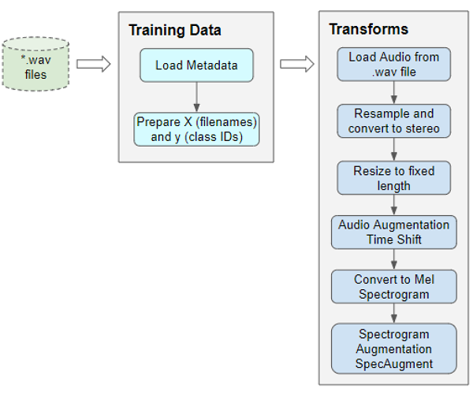the model during training.

Pre-processing the training data for inp

## **Read audio from a file**

The first thing we need is to read and load the audio file in “.wav” format. Since we are using Pytorch for this example, the implementation below uses torchaudio for the audio processing, but librosa will work just as well.

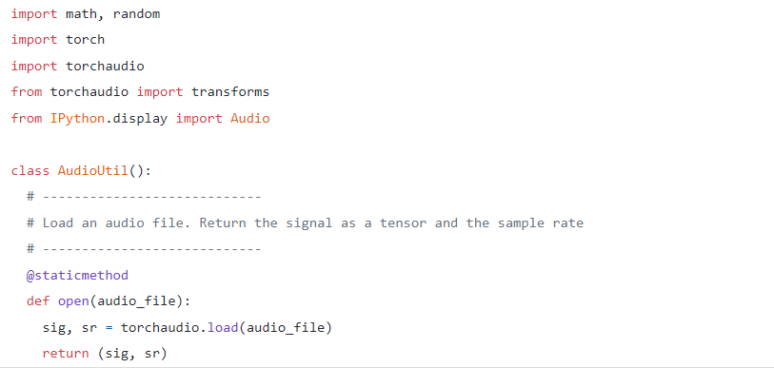

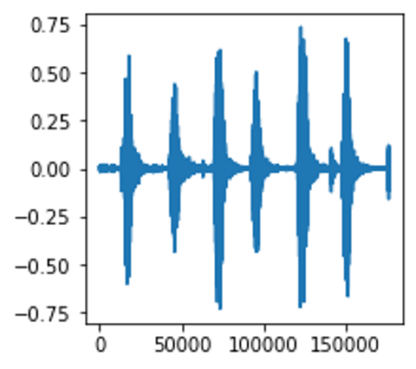

## **Convert to two channels**

Some of the sound files are mono (ie. 1 audio channel) while most of them are stereo (ie. 2 audio channels). Since our model expects all items to have the same dimensions, we will convert the mono files to stereo, by duplicating the first channel to the second.

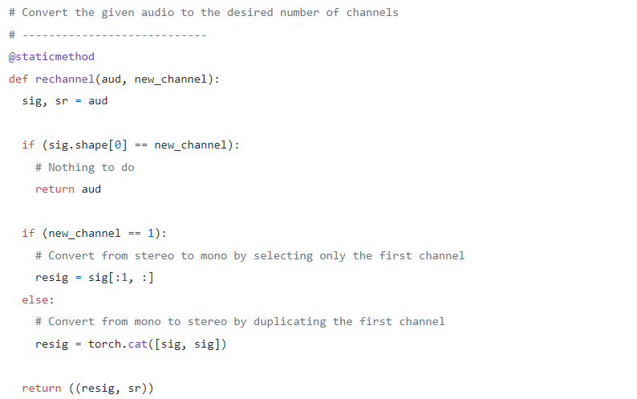

## **Standardize sampling rate**

Some of the sound files are sampled at a sample rate of 48000Hz, while most are sampled at a rate of 44100Hz. This means that 1 second of audio will have an array size of 48000 for some sound files, while it will have a smaller array size of 44100 for the others. Once again, we must standardize and convert all audio to the same sampling rate so that all arrays have the same dimensions.

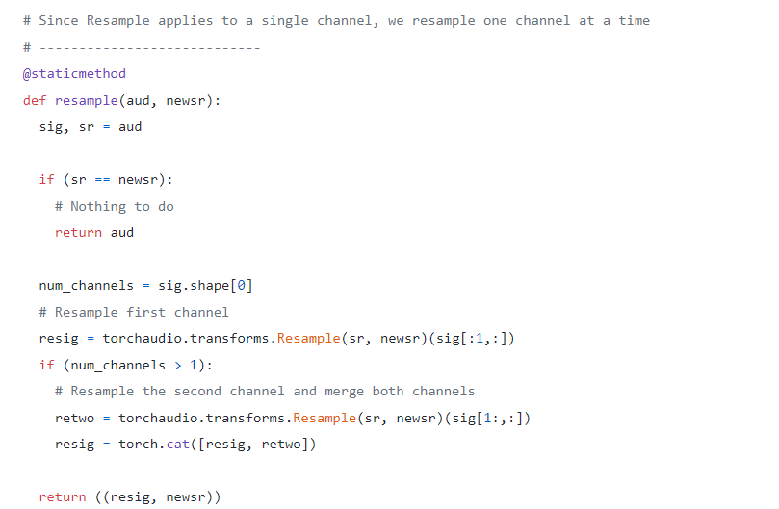

## **Resize to the same length**

We then resize all the audio samples to have the same length by either extending its duration by padding it with silence, or by truncating it. We add that method to our AudioUtil class.

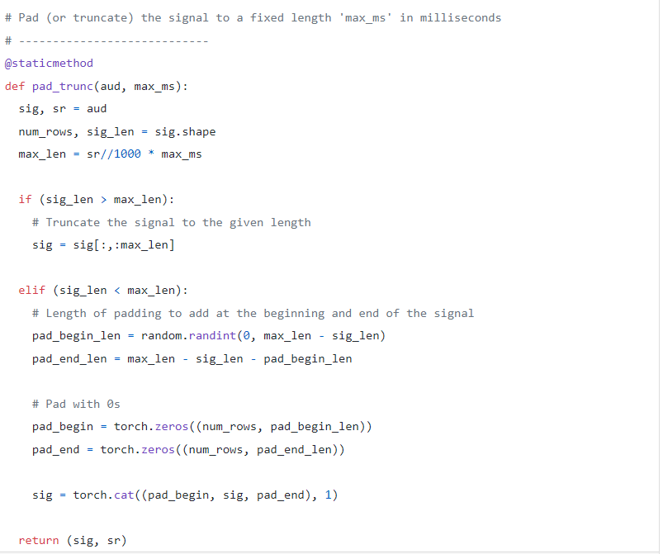

## **Data Augmentation: Time Shift**

Next, we can do data augmentation on the raw audio signal by applying a Time Shift to shift the audio to the left or the right by a random amount.

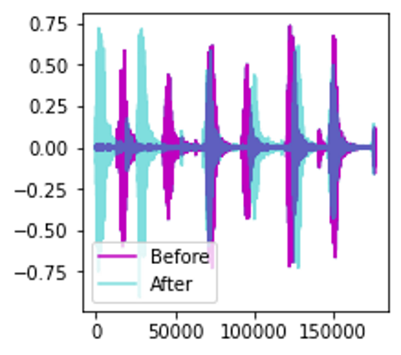

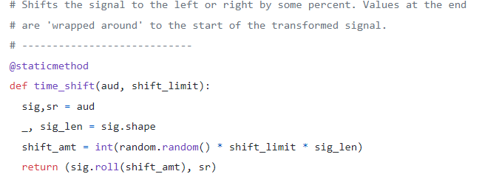

## **Mel Spectrogram**

We then convert the augmented audio to a Mel Spectrogram. They capture the essential features of the audio and are often the most suitable way to input audio data into deep learning models.

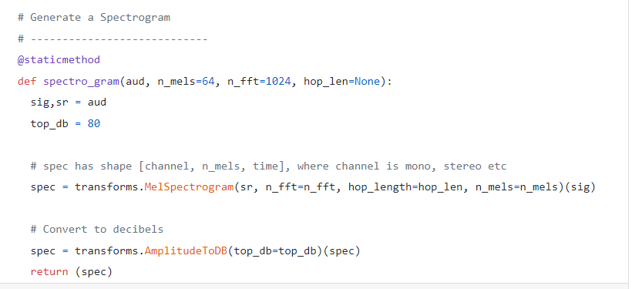

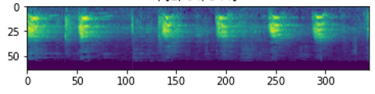

## **Data Augmentation: Time and Frequency Masking**

Now we can do another round of augmentation, this time on the Mel Spectrogram rather than on the raw audio. We will use a technique called SpecAugment that uses these two methods:

* Frequency mask — randomly mask out a range of consecutive frequencies by adding horizontal bars on the spectrogram.
* Time mask — similar to frequency masks, except that we randomly block out ranges of time from the spectrogram by using vertical bars.

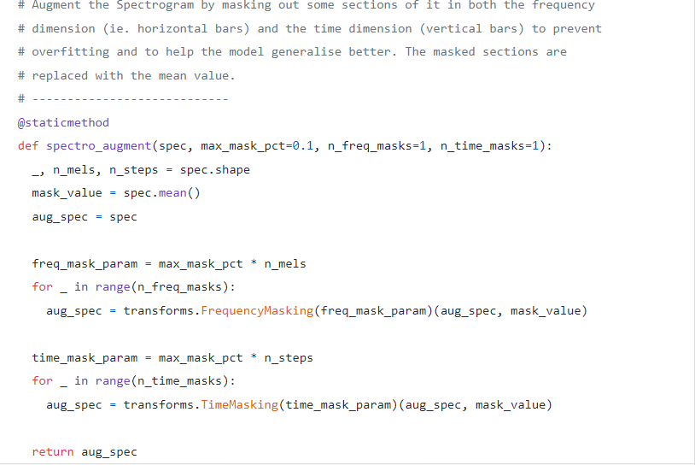

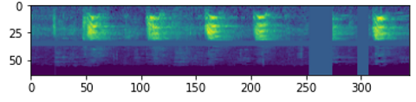**Define Custom Data Loader**

Now that we have defined all the pre-processing transform functions we will define a custom Pytorch Dataset object.

To feed your data to a model with Pytorch, we need two objects:

* A custom Dataset object that uses all the audio transforms to pre-process an audio file and prepares one data item at a time.
* A built-in DataLoader object that uses the Dataset object to fetch individual data items and packages them into a batch of data.

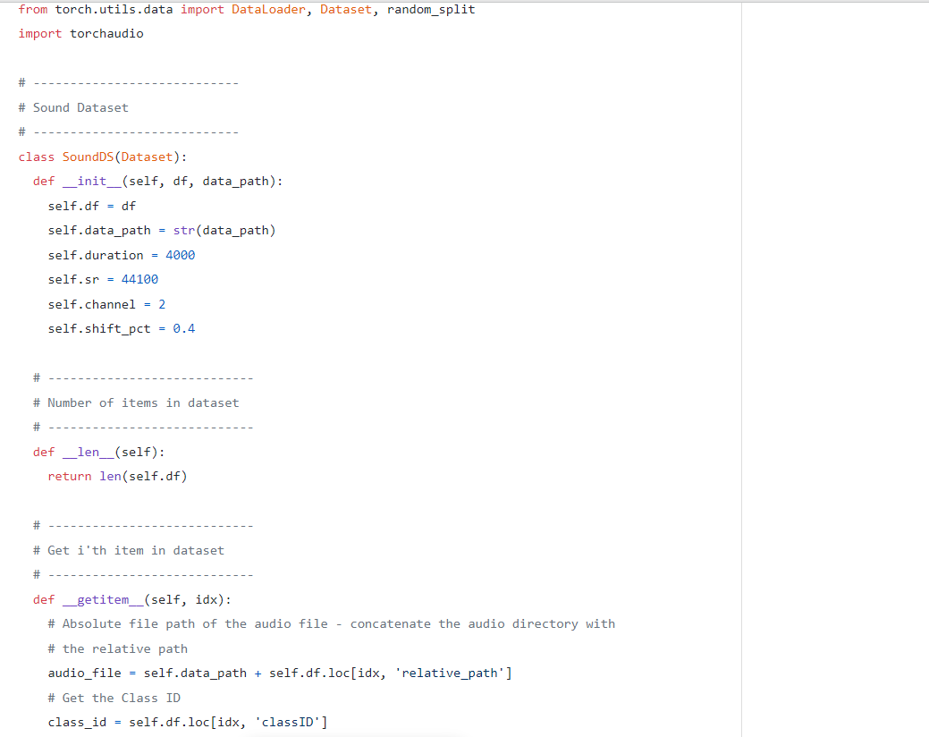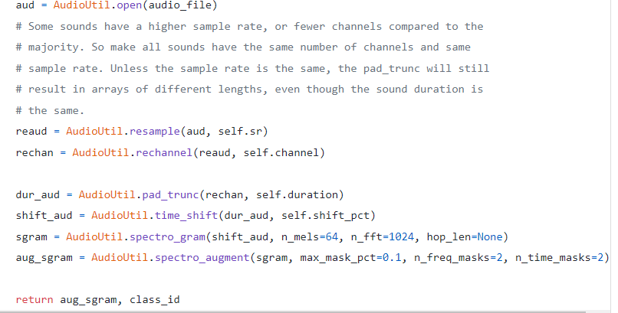**Prepare Batches of Data with the Data Loader**

All of the functions we need to input our data to the model have now been defined.

We use our custom Dataset to load the Features and Labels from our Pandas dataframe and split that data randomly in an 80:20 ratio into training and validation sets. We then use them to create our training and validation Data Loaders.

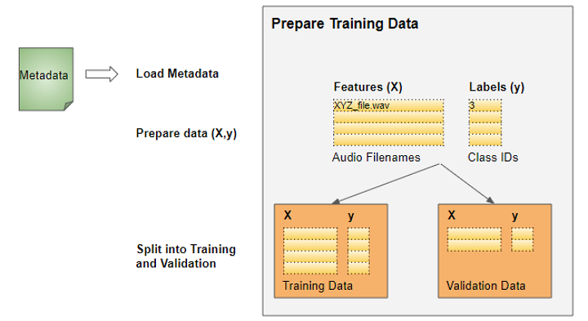

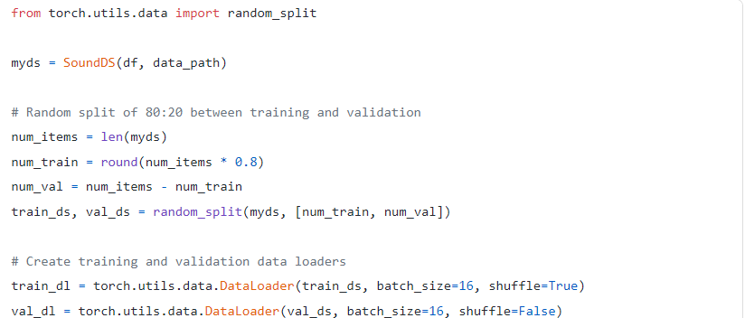

When we start training, the Data Loader will randomly fetch one batch of input Features containing the list of audio file names and run the pre-processing audio transforms on each audio file. It will also fetch a batch of the corresponding target Labels containing the class IDs. Thus it will output one batch of training data at a time, which can directly be fed as input to our deep learning model.

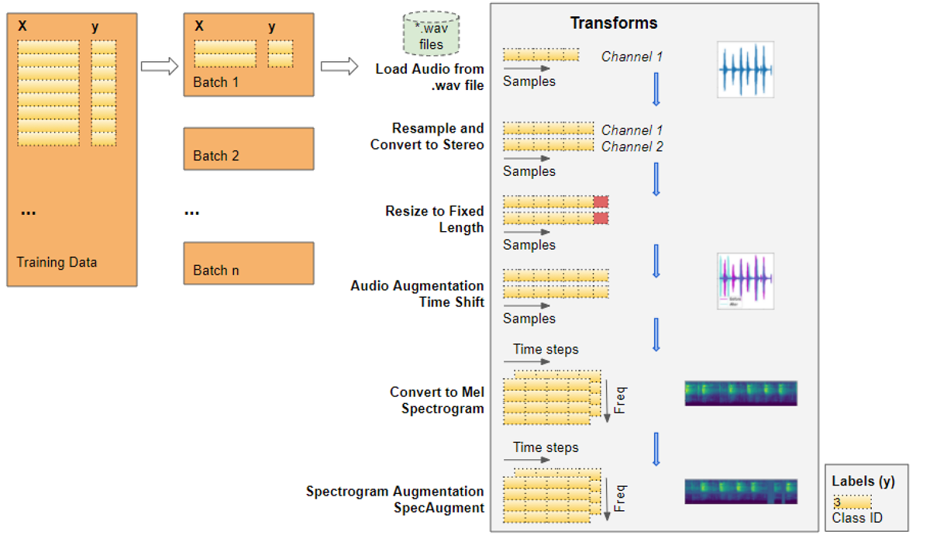

So lets go through the steps as our data gets transformed, starting with an audio file:

* The audio from the file gets loaded into a Numpy array of shape (num_channels, num_samples). Most of the audio is sampled at 44.1kHz and is about 4 seconds in duration, resulting in 44,100 * 4 = 176,400 samples. If the audio has 1 channel, the shape of the array will be (1, 176,400). Similarly, audio of 4 seconds duration with 2 channels and sampled at 48kHz will have 192,000 samples and a shape of (2, 192,000).
* Since the channels and sampling rates of each audio are different, the next two transforms resample the audio to a standard 44.1kHz and to a standard 2 channels.
* Since some audio clips might be more or less than 4 seconds, we also standardize the audio duration to a fixed length of 4 seconds. Now arrays for all items have the same shape of (2, 176,400)
* The Time Shift data augmentation now randomly shifts each audio sample forward or backward. The shapes are unchanged.
* The augmented audio is now converted into a Mel Spectrogram, resulting in a shape of (num_channels, Mel freq_bands, time_steps) = (2, 64, 344)
* The SpecAugment data augmentation now randomly applies Time and Frequency Masks to the Mel Spectrograms. The shapes are unchanged.

Thus, each batch will have two tensors, one for the *X* feature data containing the Mel Spectrograms and the other for the *y* target labels containing numeric Class IDs. The batches are picked randomly from the training data for each training epoch.

Each batch has a shape of (batch_sz, num_channels, Mel freq_bands, time_steps)



A batch of (X, y) data

We can visualize one item from the batch. We see the Mel Spectrogram with vertical and horizontal stripes showing the Frequency and Time Masking data augmentation.

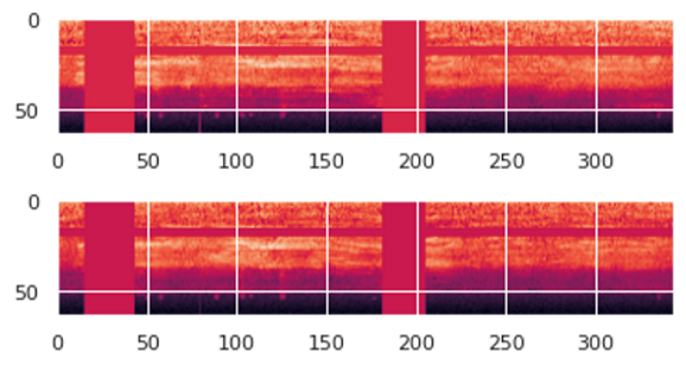

The data is now ready for input to the model.

**Create Model**

The data processing steps that we just did are the most unique aspects of our audio classification problem. From here on, the model and training procedure are quite similar to what is commonly used in a standard image classification problem and are not specific to audio deep learning.Since our data now consists of Spectrogram images, we build a CNN classification architecture to process them. It has four convolutional blocks which generate the feature maps. That data is then reshaped into the format we need so it can be input into the linear classifier layer, which finally outputs the predictions for the 10 classes.

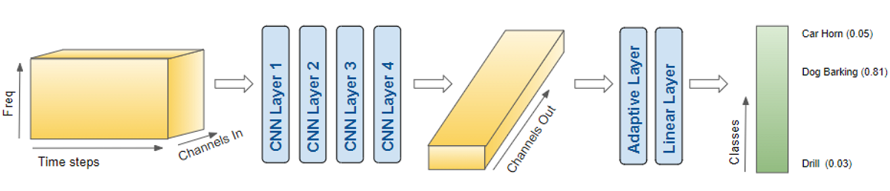

The model takes a batch of pre-processed data and outputs class predictions

A few more details about how the model processes a batch of data:

* A batch of images is input to the model with shape (batch_sz, num_channels, Mel freq_bands, time_steps) ie. (16, 2, 64, 344).
* Each CNN layer applies its filters to step up the image depth ie. number of channels. The image width and height are reduced as the kernels and strides are applied. Finally, after passing through the four CNN layers, we get the output feature maps ie. (16, 64, 4, 22).
* This gets pooled and flattened to a shape of (16, 64) and then input to the Linear layer.
* The Linear layer outputs one prediction score per class ie. (16, 10)

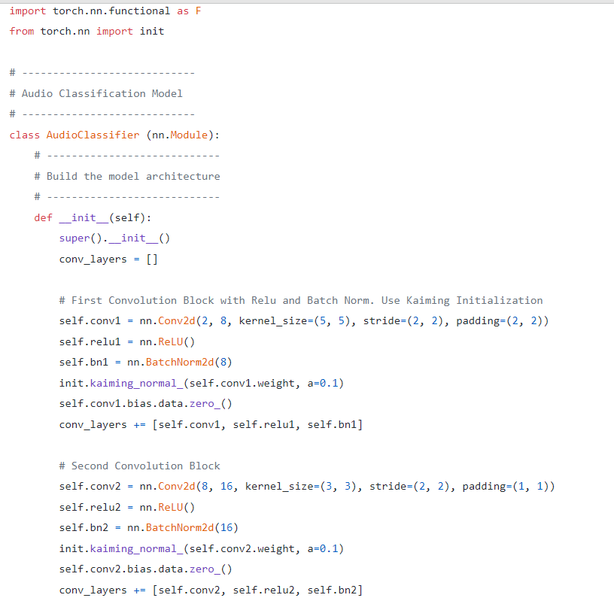

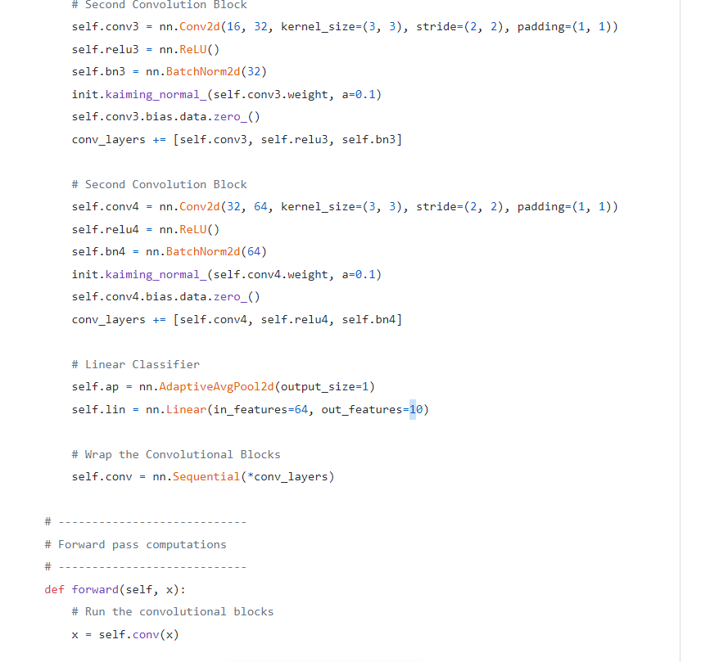

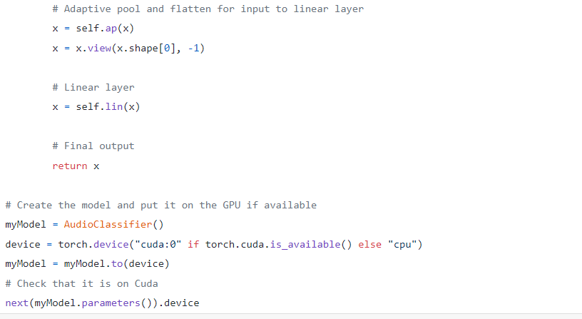

# **Training**

We are now ready to create the training loop to train the model.We define the functions for the optimizer, loss, and scheduler to dynamically vary our learning rate as training progresses, which usually allows training to converge in fewer epochs.We train the model for several epochs, processing a batch of data in each iteration. We keep track of a simple accuracy metric which measures the percentage of correct predictions.

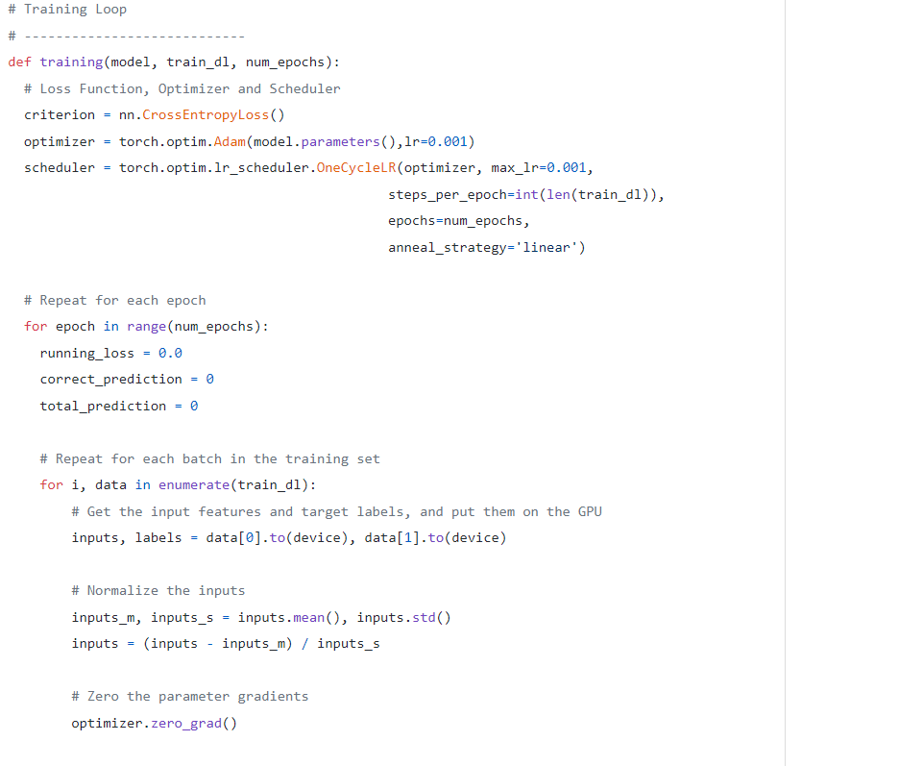

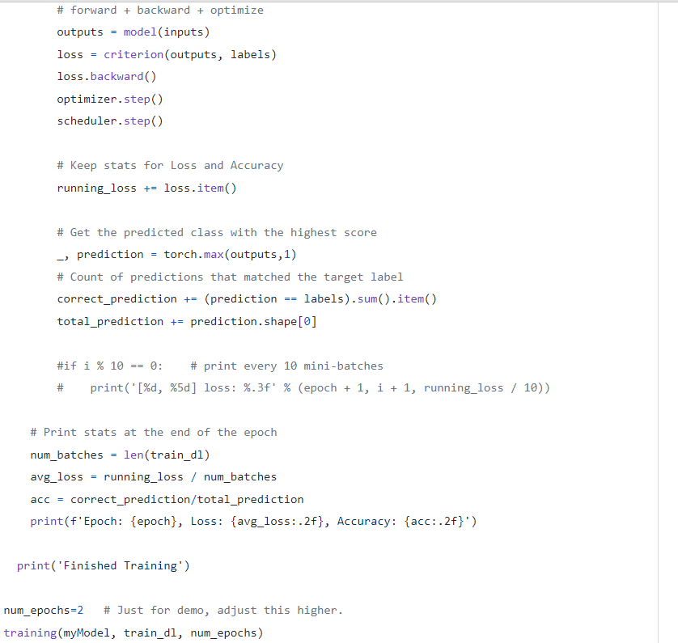

# **Inference**

Ordinarily, as part of the training loop, we would also evaluate our metrics on the validation data. We would then do inference on unseen data, perhaps by keeping aside a test dataset from the original data. However, for the purposes of this demo, we will use the validation data for this purpose.

We run an inference loop taking care to disable the gradient updates. The forward pass is executed with the model to get predictions, but we do not need to backpropagate or run the optimizer.

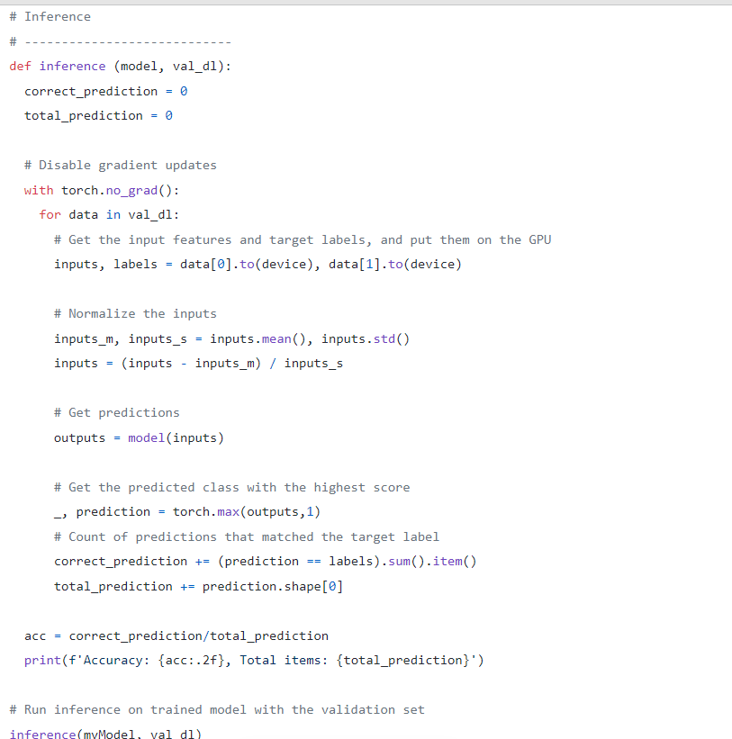**Conclusion**

We have now seen an end-to-end example of sound classification which is one of the most foundational problems in audio deep learning. Not only is this used in a wide range of applications, but many of the concepts and techniques that we covered here will be relevant to more complicated audio problems such as automatic speech recognition where we start with human speech, understand what people are saying, and convert it to text.And finally, if you liked this article, you might also enjoy my other series on Transformers, Geolocation Machine Learning, and Image Caption architectures.